Trading Strategy – Summary (Long Trade Example)

- Identify major S/R (monthly then weekly) – to round number
- Identify trend (zoomed out daily chart)
- Look for significant pullback to:
  - Major S/R
  - 50% fib of last upswing
  - Trend Line
  - (b and c must be in combination)
- Look for the following price action at round numbers:
  - Pin (hammer/shooting star)
  - Outside/Engulfing
  - Inside
- Entry 12 pips above trigger; stop loss 12 pips below trigger
- Position size – 2% of equity
- If stopped out move on to next trade
- If moves into profit move SL to BE at first stall point
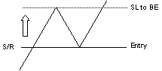
- Add to position at next opportunity as above
- Exit when trend changes

